NFOrce Entertainment B.V.
support@nforce.com
Abstract
Controlling your VM, reinstalling, starting, stopping, and accessing the remote control
How to control your VM

Intro
Thank you for your purchase of a Virtual Server, or most known as “VPS” or “Cloud Solution”. In this document we will explain how you can control the Virtual Server.

Contents
Intro 1
1. Log onto the dashboard 3
2. Controlling your VM’s 4
3. Rebuilding the Virtual Machine. 5
4. Using ISOs 6
5. Important notes 8

Log onto the dashboard
Once you are ready, you can open up your webbrowser and browse to the url: https://controlpanel.onapp.vps.nforce.com/
Once you have opened the page, you will receive a login screen:
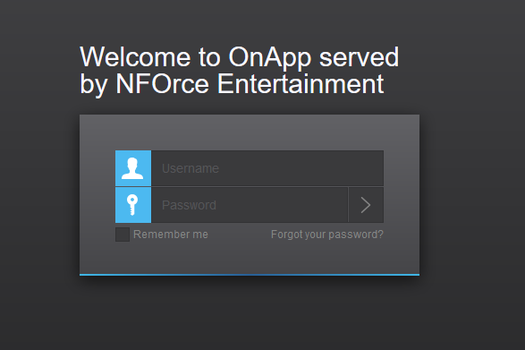
Fill in your details you have received from us to log into the system. Once your password has been accepted you will be presented by the dashboard.
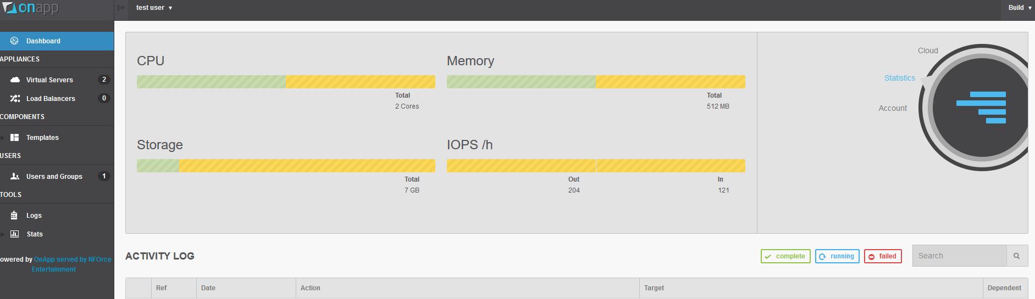

Controlling your VM’s
Just by clicking on “Virtual Servers”, you will see the list of VM’s you control:
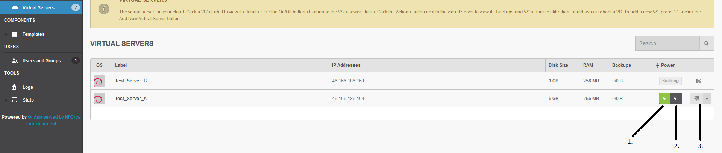
As you can see on the Image, I have noted 3 important items you might need to use.
- This is the power ON button
- This is the power OFF button
- This is the settings menu, you have 3 more options here for reboot, shutdown and reboot into recovery.
If you click on the name of a VM, you will get more options:
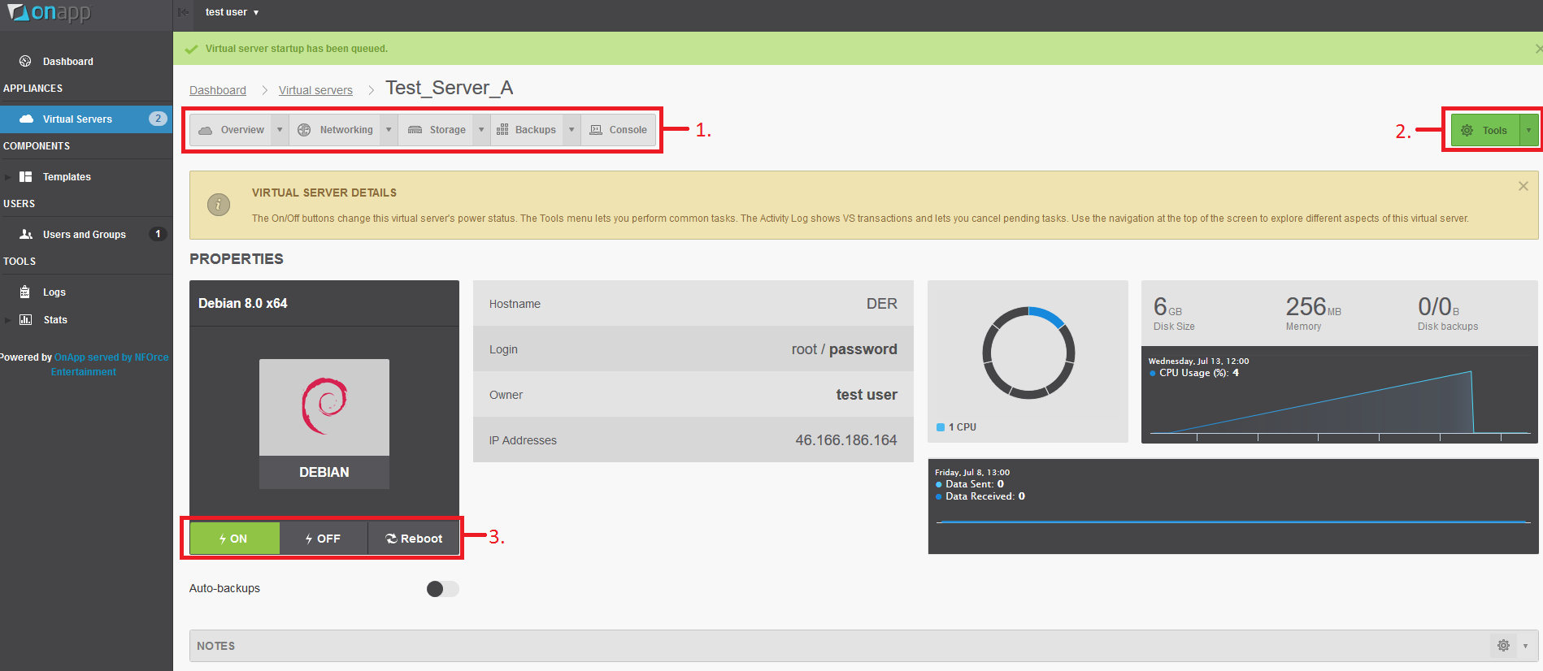
Also here I have noted down the important parts of this.
- Are a few buttons for options, such for billing (if applicable), network details, storage details and backups (if applicable). The most important option here is the “Console”, when it is required you can connect to the console using this if you need to debug the VM.
- This is the settings menu, with several options, such as reboot, re-install/rebuild the VM, and some other basic tasks as in the first menu.
- These are the power buttons again, simply stating clearly On, Off and Reboot.
Now this is known, in the next chapters we will show you how to rebuild / reinstall the VM

Rebuilding the Virtual Machine.
To rebuild the Virtual Machine, click on the Tools menu at the top right (Green button) and select “Rebuild Virtual Server”. Select your preferred OS, and the system will re-deploy the image for this.
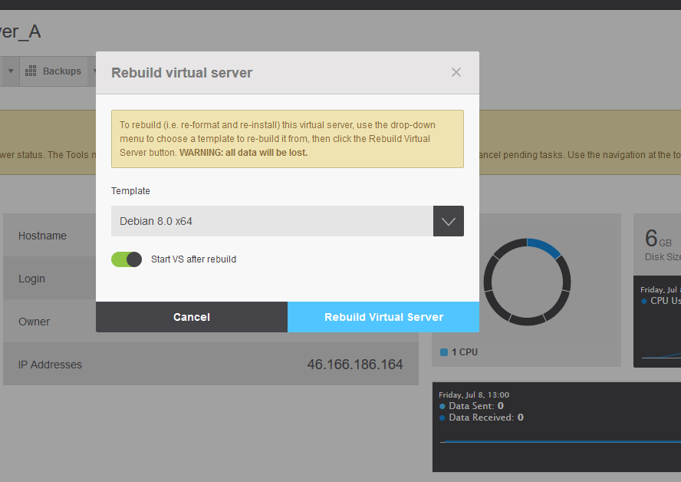
Keep in mind that these are deploy images, so the install is fully automatic and can be completed in several minutes. It will use the password that is hidden under the word “Password” at the main detail screen of the VM, by clicking on the word Password, will reveal the password.

Another way to re-install your system is using the ISO system.

Using ISOs
Notice: Backups are not supported on system installed by ISO. When you reinstall the system with an ISO, there is no guarantee for backups if a massive system failure takes place.
Notice: If your ISO is not available, please contact NFOrce Entertainment B.V. (support@nforce.com) s so we can upload your desired ISO. We do recommend template installation rather than ISO installation due to the support of the backup system.
If you need to use an ISO, you will have to manually install the system. Click on the Tools menu at the top right (Green button), and select Boot from ISO. Select an ISO from the menu and let the system boot.
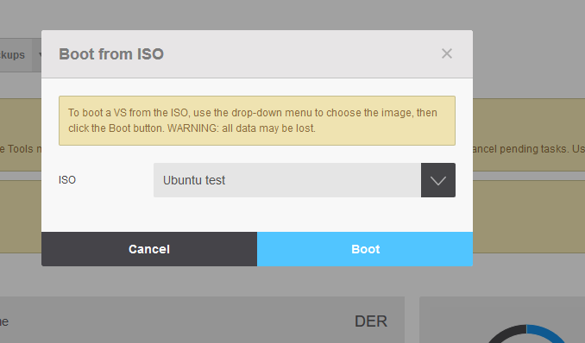
At the main detail screen of the VM, you can select “Console” from the top menu bar to connect to the screen so you can control the system from there.
It is normal that after selecting boot the system will become locked for the reboot period.

Once this is completed the VM is unlocked and you can connect to the Console.
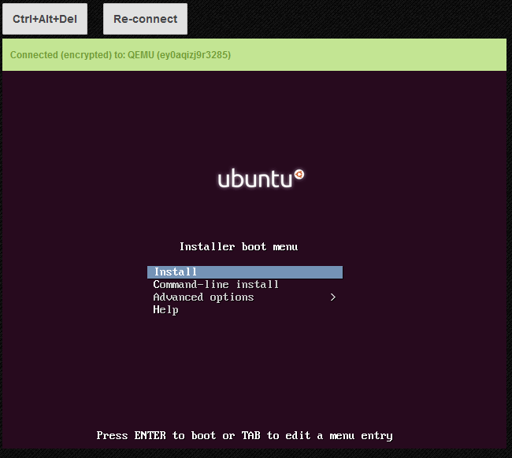

Important notes
As customer, you do not have access to upload ISO’s or setup deployment images. If you require specific ISO/Deploy Image, please let us know by contacting Support@NFOrce.com – Please keep in mind that it is not allowed (in case of windows) to have custom ISO’s with illegal tools. Also the ISO/deploy images will be publicly for everyone available.
If you need an ISO/Deploy Image, we only accept the original source of these images.

